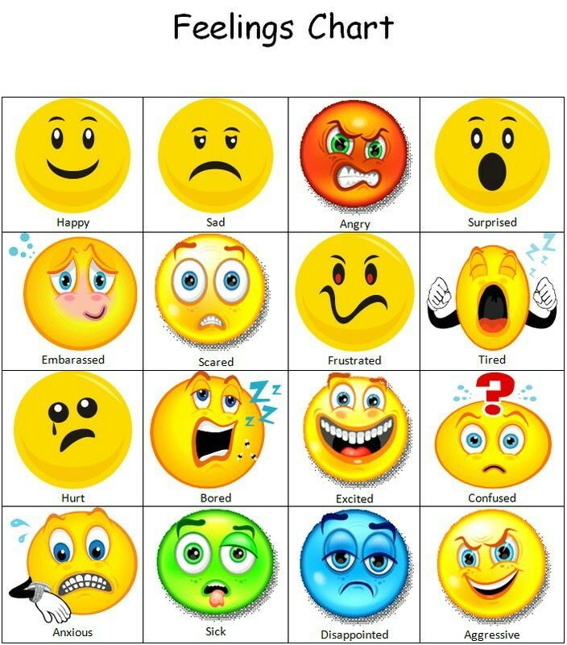
Talking about positive feelings
Objectives: Students will:
- Identify different feelings
- Identify the positive feelings
- Relate the feelings to themselves
Materials:
Chart paper and markers or whiteboard
Paper to draw and write on
Pencils, crayons, markers

Activity 1: There are many kinds of good feelings: You can feel happy, silly, calm, safe, relaxed, proud, or excited.
What other types of feelings would you consider to be “good” feelings?
What makes you feel good?

Activity 2: Pick 3 of the feelings from the chart and write about/draw a picture when you recently felt any of these feelings.

Activity 3: From the chart can you separate the positive feelings (happy) from the negative (sad) feelings. Are there any feelings that are not positive or negative?

Activity 4: Today I’m going to share some short stories with you and you’re going to think about how you’d feel if you were in each story. After you decide how you’d feel, you’ll come up to the board and tape your name card under the face that shows how you’d feel.
After reading each situation, ask the following questions: Why would you feel that way in that story? Do you think it’s OK for other people to feel different than you would? Why?
Extensions:
- Kids can make up other scenarios and share them with the class.
- Kids can work in small groups to role-play each of the scenarios

Situation 1
It’s time for break time! You’re planning to play on the swings, but when you get to the playground, all the swings are being used. How do you feel?
Situation 2
Your parents tell you that they are going to buy you a present. How do you feel?
Situation 3
You’re at a theme park waiting in line to go on a roller coaster that goes really fast and high. How do you feel?
Situation 4
You painted a really pretty picture in art class and the teacher holds it up to show everyone. How do you feel?
Situation 5
You have not been in school and around your classmates for a long time. Now you are seeing some of your friends.

Talking about Negative Feelings

Objectives:
Students will: Define the negative feelings
Identify and discuss how they would feel if they were involved in a variety of scenarios provided by the teacher

Activity 1: Look at the eight faces,

- angry,
- embarrassed,
- anxious,
- sad,
- scared,
- hurt,
- anxious,
- disappointed.

Have you ever felt any of these feelings before? Can you describe/draw a picture of what happened and what you felt?

Activity 2: Today I’m going to share some short stories with you and you’re going to think about how you’d feel if you were in each story. After you decide how you’d feel, you’ll come up to the board and tape your name card under the face that shows how you’d feel.
After reading each situation, ask the following questions: Why would you feel that way in that story? Do you think it’s OK for other people to feel different than you would? Why?
Extensions:
- Kids can make up other scenarios and share them with the class.
- Kids can work in small groups to role-play each of the scenarios

Feelings and Faces Note to instructor:
After reading each situation, let the students write down the face that describes their feelings related to each situation. Ask the kids to explain why they feel that way.

Situation 1
It’s the end of the school day. Parents have already picked up all your classmates, but nobody has come to pick you up.
Situation 2
You and your friends are playing a board game. All of a sudden your younger brother dog runs through the living room and messes up your game. Game pieces go flying and the game is finished. How do you feel?
Situation 3
Your parents are going to go out in the evening and a babysitter is coming to watch you while your parents are gone. How do you feel?
Situation 4
Your best friend invited you to a play date on Sunday. But that morning, your friend’s mother calls to say that your friend is sick, and the play date is cancelled. How do you feel?

You can then include some present-day situations
Here are some examples: you can make up your own according to the situations which arise.
Situation 1- A person near you coughs and says that they feel unwell
Situation 2- Your best friend is not in school today and you are not sure why

